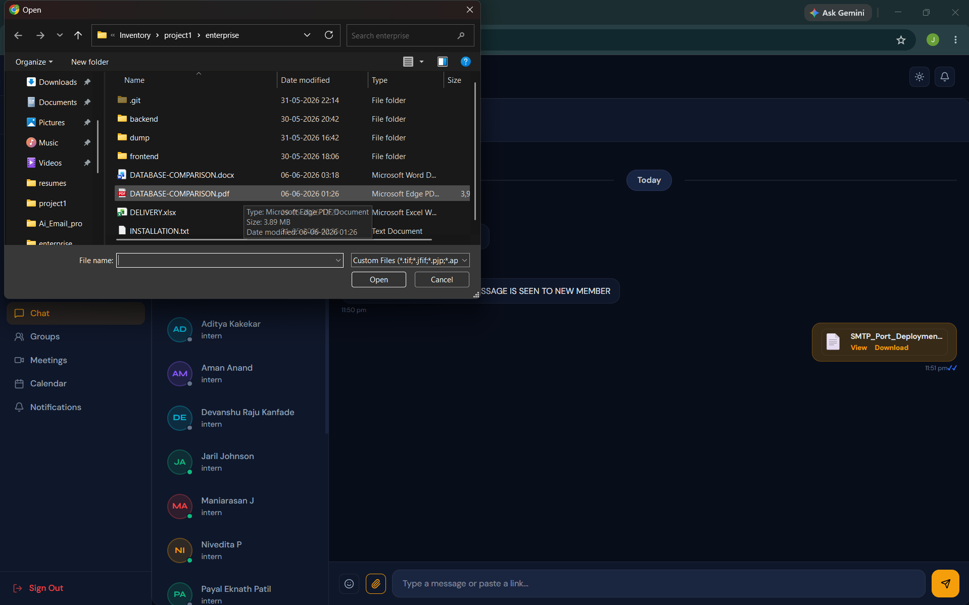
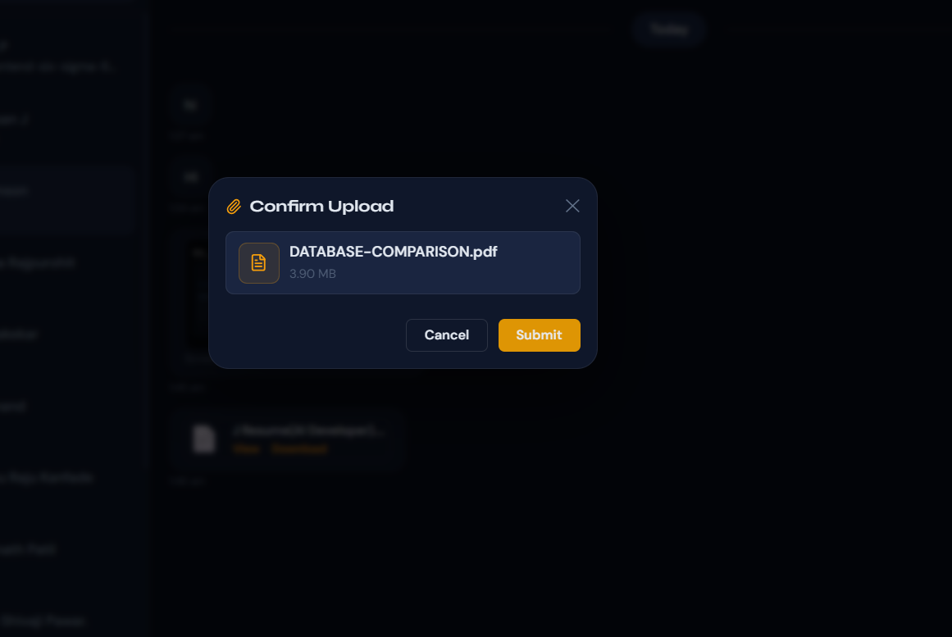

Pdf IS NOT SENDING kb FILES ARE SENDING CANT SEND MB FILES

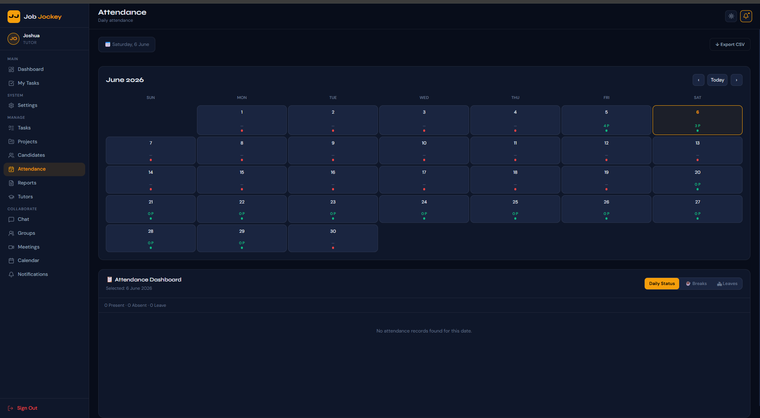
TUTOR CANT SEE THE PRESENT,ABSENT,LEAVE CANDIDATE

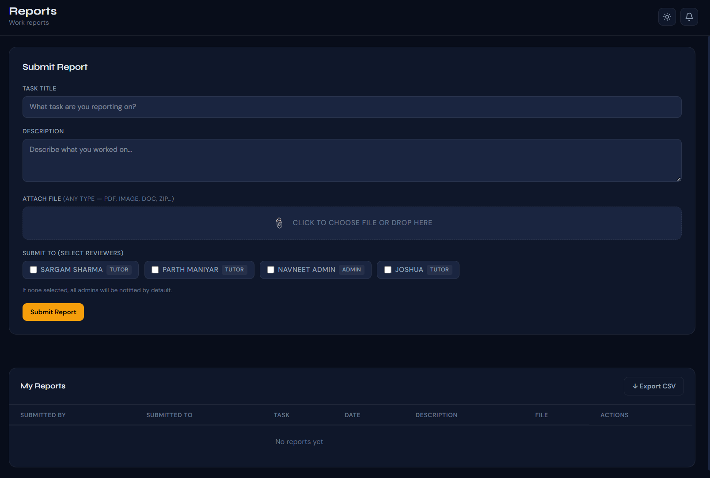

SUBMITTED REPORT IS NOT SHOWINH IN FROM CANDIDATE SIDE

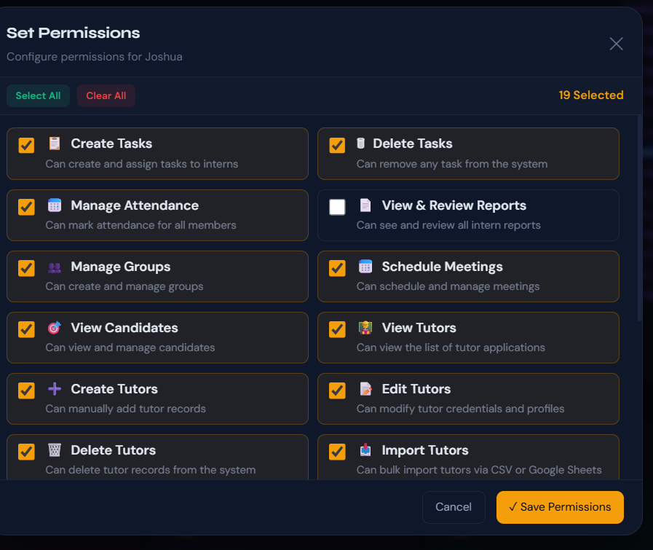
When tutor don’t have the permission to review or view reports. Tutor still view , manage report
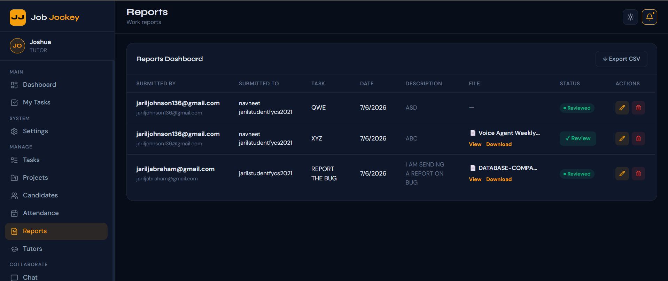

REPORT ARE SEEN BY ALL TUTOR , EVEN IF REPORT ARE NOT SUBMIT TO THEM

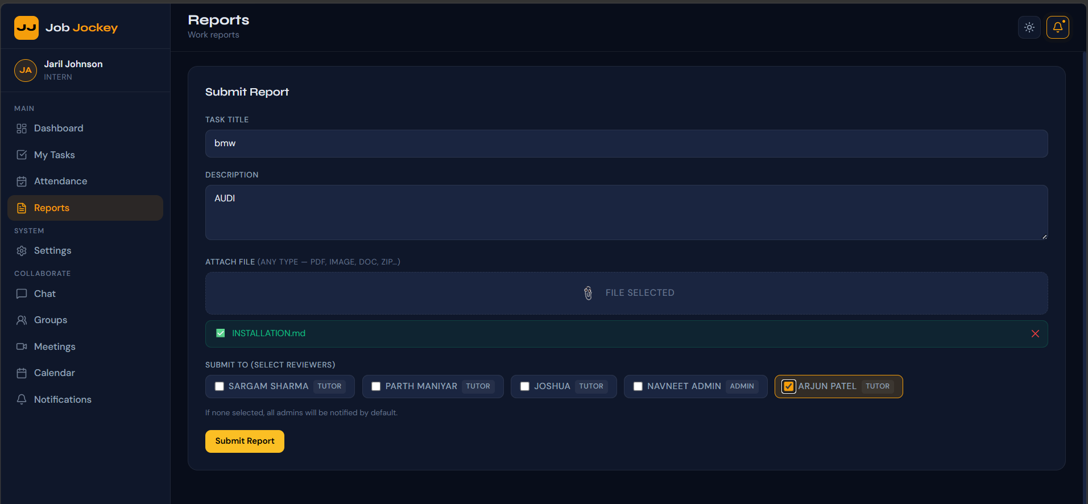\

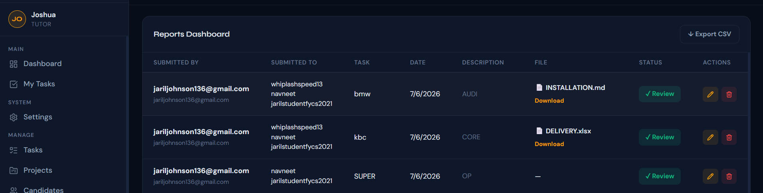
Its sometimes send to other tutor like if report submitted to Navneet , then Jaril will also get it . and when report is submitted to arjun , then Navneet, Jaril, arjun will get the report

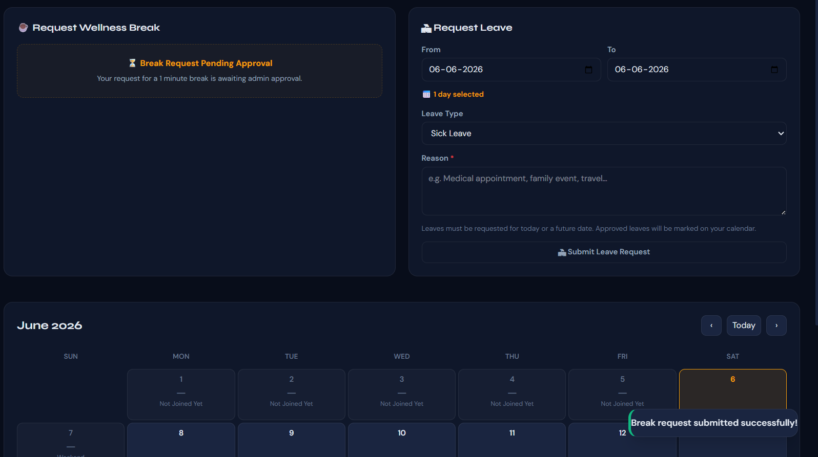
GUI IS TO COMPACT WHEN BREAK IS REQUESTED

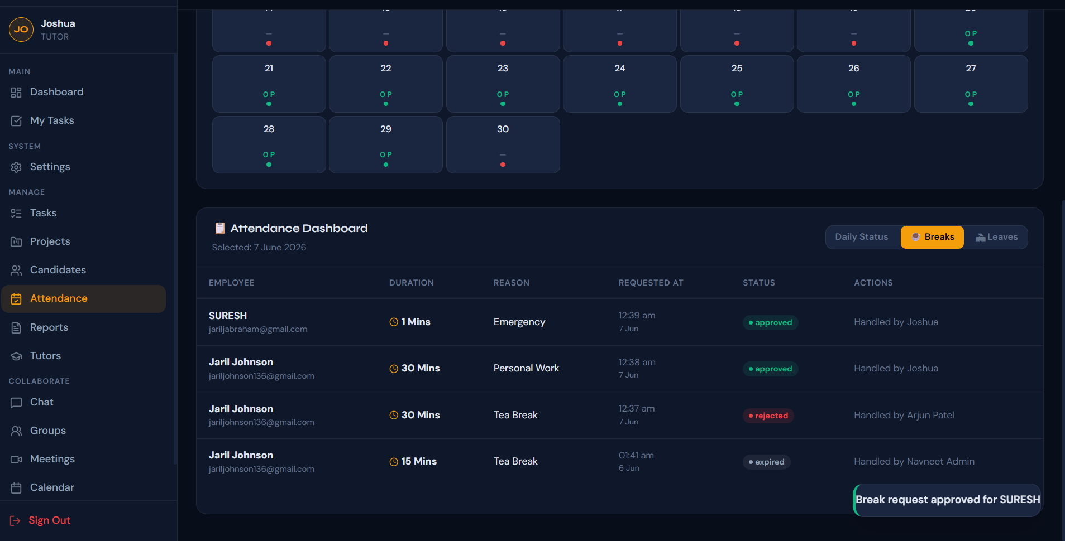SAME UI BUG IN TUTOR SESSION
SAME UI BUG WHEN LEAVE REQUEST

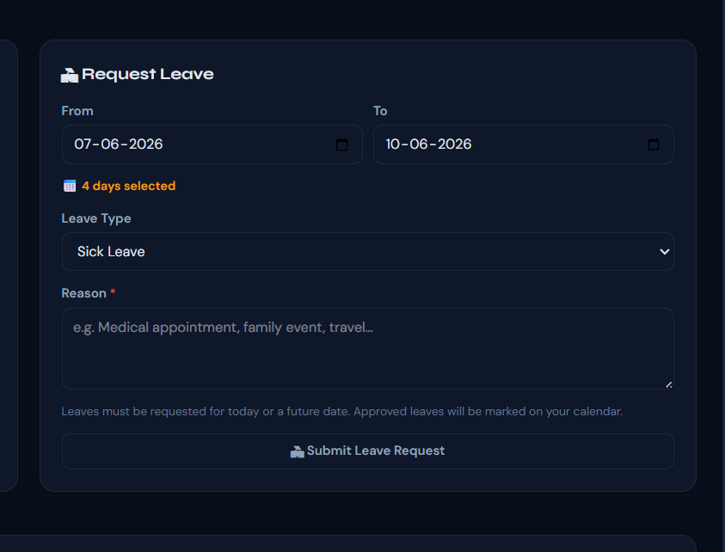

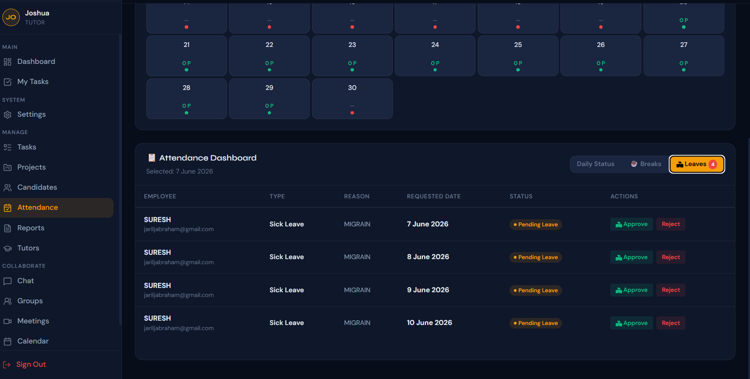
MULTIPLE SEPRATE LEAVE REQUEST IS COMING

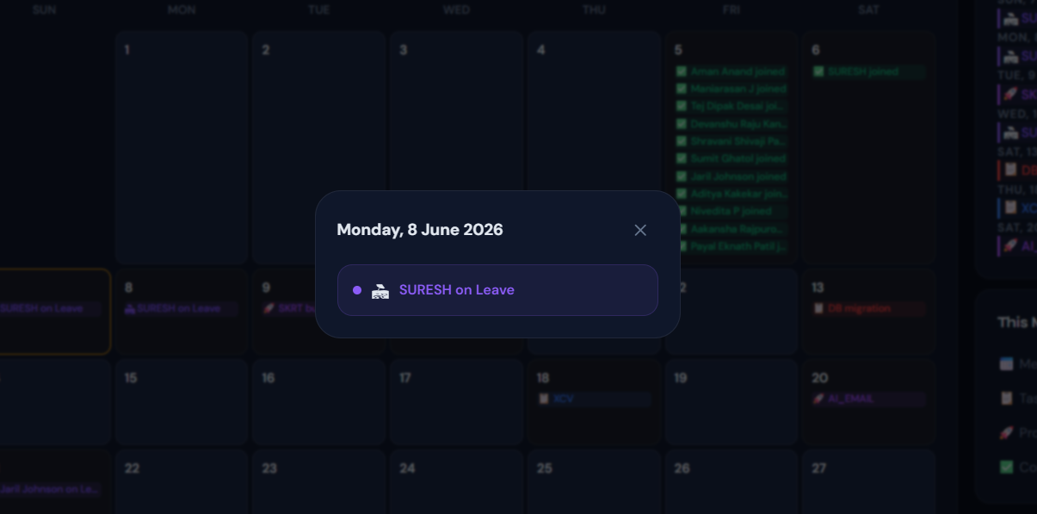
WHEN A TUTOR GRAND LEAVE THE TUTORS NAME , AND REASON FOR LEAVE SHOULD BE SHOWN IN ADMIN

